Task 16

Q1.

Open the Firefox Browser ,Maximizes the Browser window, then navigates to the [www.google.com](http://www.google.com), get the url and print the url , reload the page and close the browser.

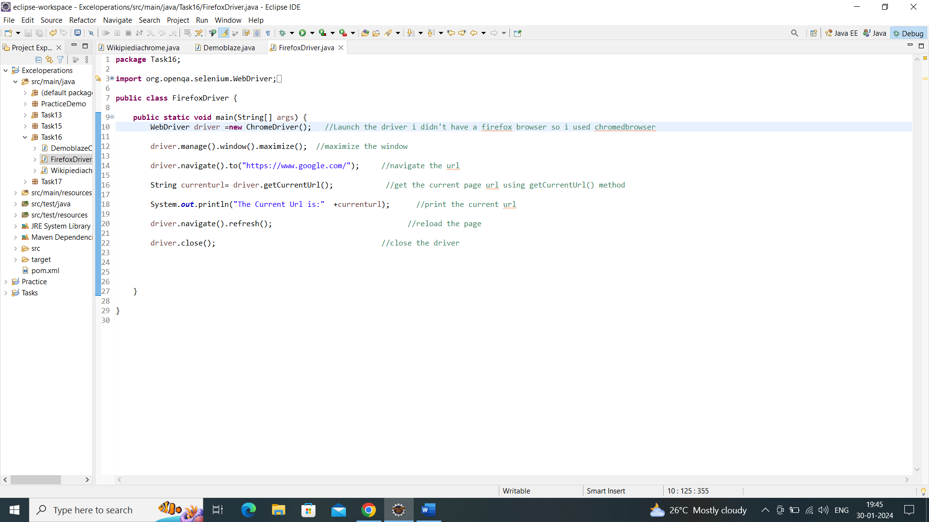

Output:

Open the browser ,load the url,and reload the page.

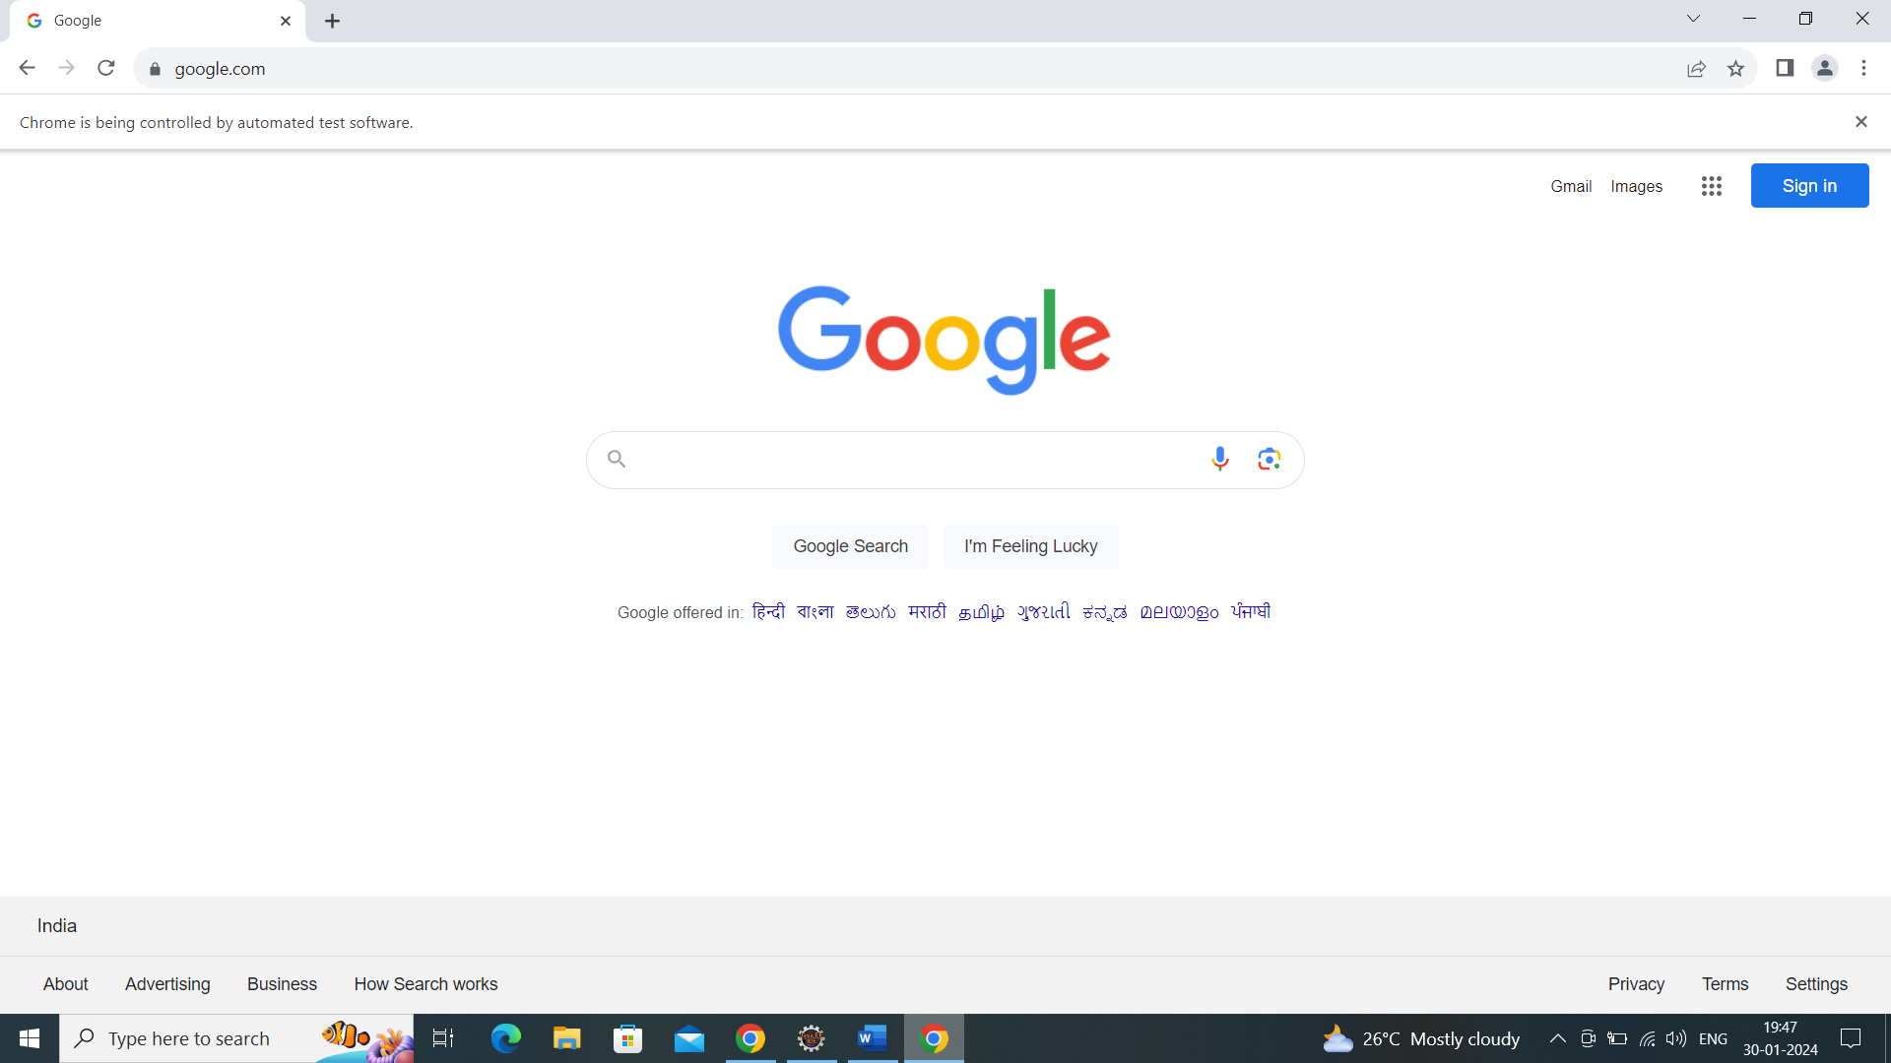

Current url in console

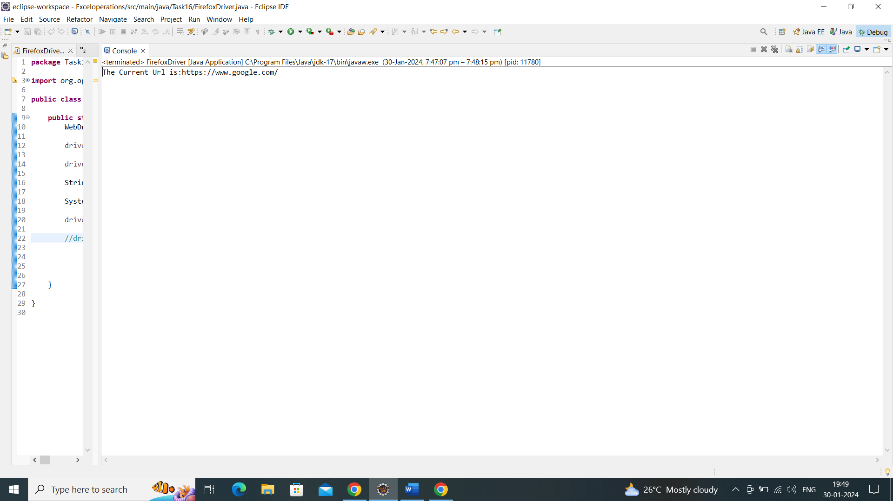

Q2.Open the chrome browser ,navigate the url [www.demoblaze.com,maximize](http://www.demoblaze.com,maximize) the browser window, validate the page using pagetiltle and print the outputin console.

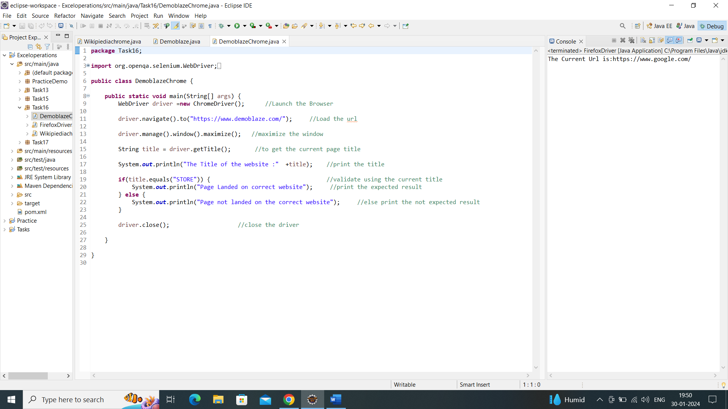

Output:

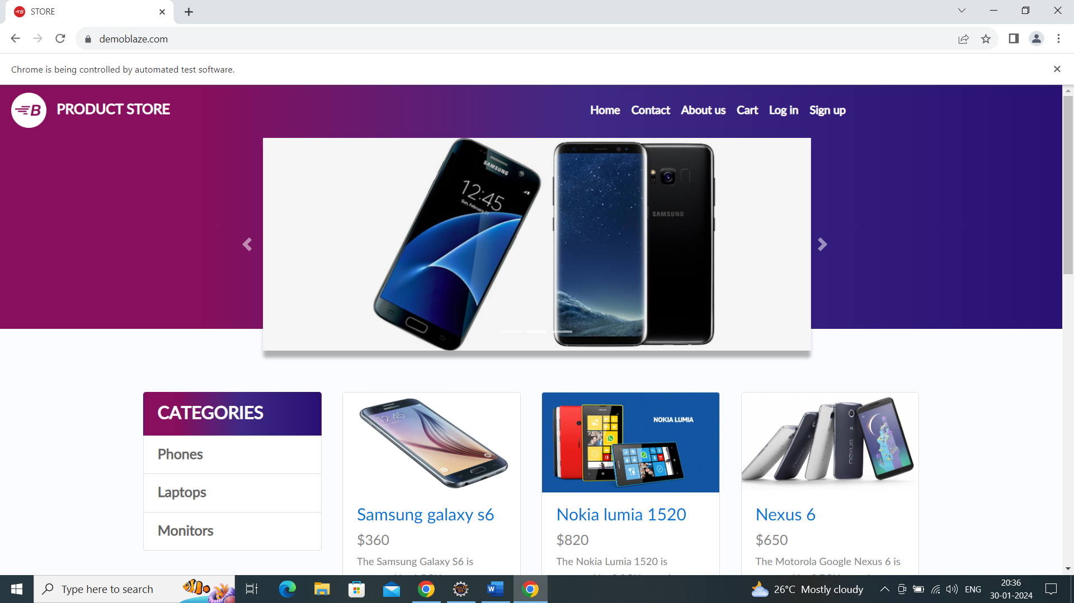

Console output:

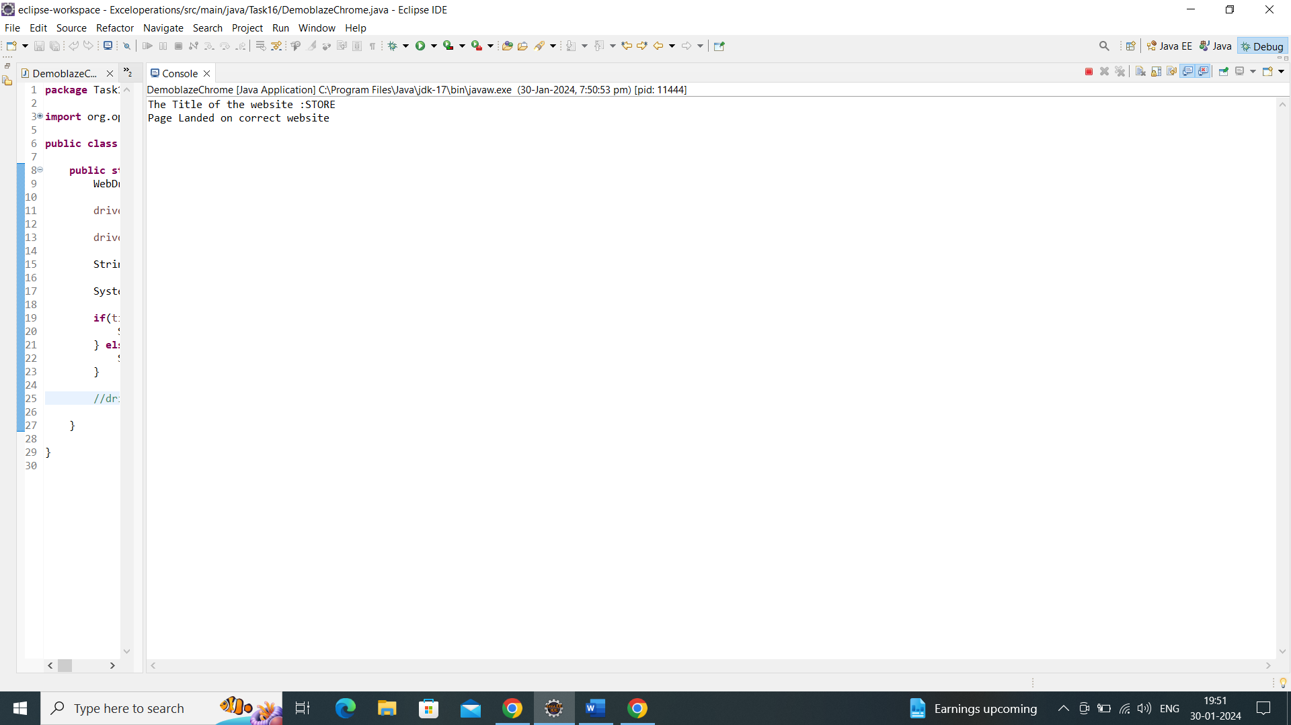

Q3.Open the Chrome browser, navigates the url [www.wikipidia.com](http://www.wikipidia.com) , and search the title for Artificial intelligence, then click the history section and print the title of the section.

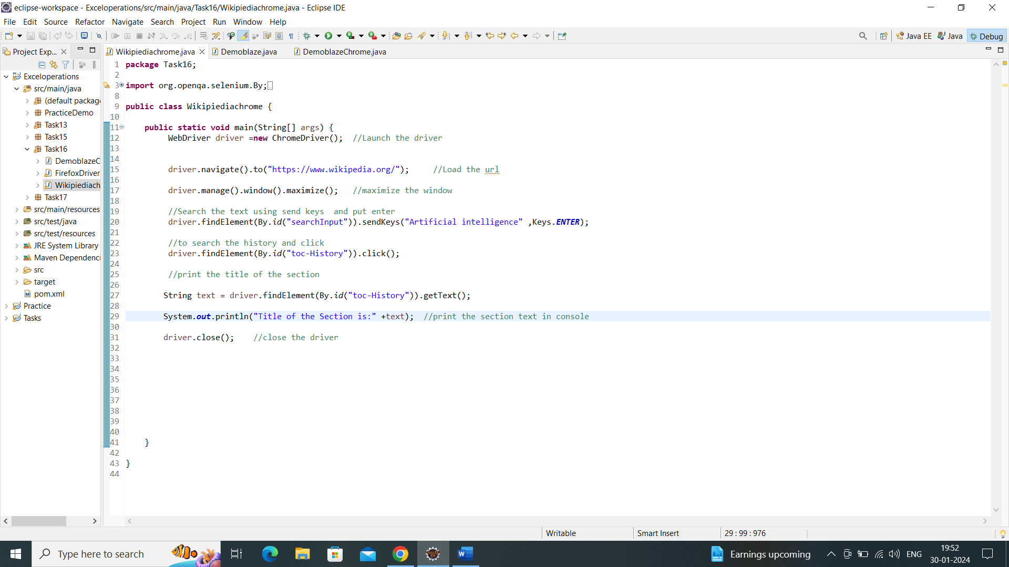

Output:

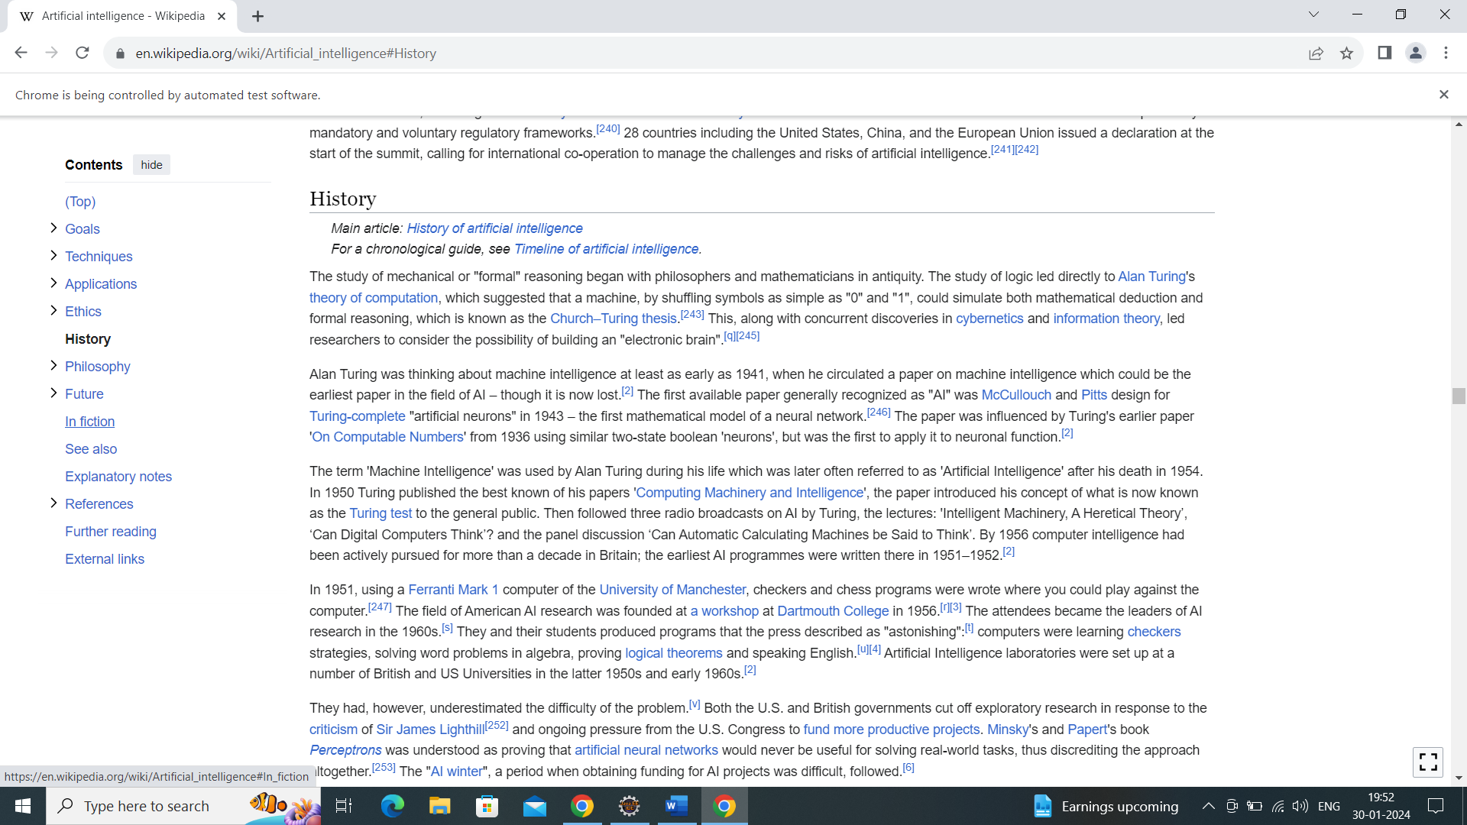

Console output:

